Year 12 Chemistry Assignment - Solutions

Due with Validation on Monday 3rd April

(71 marks)

Topic E: Acids and Bases Name _________________________

Multiple Choice (1 mark each)

1. The usual purpose of a titration is to

- create a primary standard
- determine the volume needed for reactants to react with each other
- create a secondary standard
- find the concentration of a solute in a solution ✓

2. An acid-base titration is performed by

- adding one solution from a pipette to a carefully measured volume which is placed in a conical flask.
- adding one solution from a pipette to a carefully measured volume which is placed in a volumetric flask.
- adding one solution from a burette to a carefully measured volume which is placed in a conical flask. ✓
- adding one solution from a burette to a carefully measured volume which is placed in a volumetric flask.

3. In pure water the concentration of H⁺(aq) and OH⁻(aq) ions is equal to

- 1 x 10⁻⁷ M ✓
- 1 x 10⁻¹⁴ M
- 1 x 10⁻⁷ mol⁻¹
- 1x 10⁻¹⁴ mol⁻¹

4. The Bronsted-Lowry definition for acids and bases defines a base as

- a substance which accepts a proton ✓
- a substance that donates a proton
- a substance that produces H⁺ in solution
- a substance that produces OH⁻ in solution

5. The ethanoate ion CH₃COO⁻ causes a solution to have a pH

- equal to 7
- less than 7
- greater than 7 ✓
- that may be neutral or greater than 7 depending on the concentration of the ion.

6. An acid plus a metal produces

- salt + carbon dioxide gas
- salt + sulphur dioxide gas
- salt + water
- salt + hydrogen gas ✓

7. An acid plus a metal sulfite produces

- salt + water + sulphur dioxide gas ✓
- salt + hydrogen sulphide gas
- salt + water + sulphur trioxide gas
- salt + hydrogen gas + sulphur

8. OH⁻ plus an amphoteric metal hydroxide produces

- complex ion + water
- complex ion + water + hydrogen gas
- complex ion + hydrogen gas
- complex ion ✓

9. OH⁻ plus an amphoteric metal plus water produces

- complex ion + water
- complex ion + water + hydrogen gas
- complex ion + hydrogen gas ✓
- complex ion

10. The following are amphoteric metals

- Al, Mg, Zn
(B) Al, Na, Fe
(C) Al, Cr, Zn ✓
(D) Al, Ca, Zn

11. Which one of the following compounds, when dissolved in water,
would form a solution with a pH greater than 7?

(A) NH₄Cl
(B) Ba(NO₃)₂
(C) NaCH₃COO ✓
(D) H₃PO₄

12. Which, if any, of the following equations represents a reaction in
which water acts as an acid?

(A) CH₃COOH(aq) + H₂O(l) -----> CH₃COO⁻(aq) + H₃O⁺(aq)
(B) Zn²⁺(aq) + 4H₂O(l) -----> Zn(H₂O)₄²⁺(aq)
(C) NH₃(aq) + H₂O(l) -----> NH₄⁺(aq) + OH⁻(aq) ✓
(D) NaOH(s) -----> Na⁺(aq) + OH⁻(aq)

13. In deciding which of two acids is stronger, one must know:

(A) the concentration of each acid solution
(B) the pH of each acid solution.
(C) the K_{a} of each acid ✓
(D) all of the above

14. The conjugate acid of the HPO₄²⁻ ion is

(A) H₃PO₄
(B) H₂PO₄⁻ ✓
(C) HPO₄²⁻
(D) PO₄³⁻

15. Is the ion HPO₄²⁻ an amphoteric substance?

(A) yes ✓
(B) no
(C) sometimes
(D) unable to determine from the given information

16. 100 mL of a 0.010 M solution of barium hydroxide (Ba(OH)₂) is diluted by adding 900 mL of water at 25ºC. The pH of the resulting solution will be
10 times dilution. Therefore c(Ba(OH)₂) = 0.0010 M
c(OH-) = 0.0020 M
pOH = -log(0.0020) = 2.70
pH = 14-2.70 = 11.30
(A) 2.00
(B) 2.70
(C) 11.00
(D) 11.30 ✓

17. In which one of the following pairs is the second substance the stronger acid than the first?

(A) HCl CH₃COOH
(B) H₂PO₄⁻ H₃PO₄ ✓
(C) H₂SO₄ H₂CO₃
(D) H₂O OH⁻

18. When the pH of a solution changes from 9 to 12 the

(A) hydroxide ion concentration increases by a factor of 3
(B) hydrogen ion concentration increases by a factor of 3
(C) hydroxide ion concentration decreases by a factor of 1000
(D) hydrogen ion concentration decreases by a factor of 1000 ✓
[H+] reduces from 10⁻⁹M to 10⁻¹²M
10⁻⁹/10⁻¹² = 1000

19. 10 mL of 0.1 M HCl is added to 1.0 L of water. The pH of the resulting solution is most nearly
n(H+) = cV = 0.1 x 0.010 = 0.0010
V = 1.01 L
[H+] = n/V = 0.0010/1.01 = 9.9 x 10⁻⁴
pH = -log[9.9 x 10⁻⁴] = 3
(A) 1
(B) 2
(C) 3 ✓
(D) 4

20. 18.0 g of magnesium is added to 200 mL of 2.00 M HCl. The mass, in grams, of magnesium that is left behind after the reaction is closest to
n(Mg) = m/M = 18.0/24.3 = 0.741
n(HCl) = cV = 2.00 x 0.200 = 0.400
Mg + 2HCl => MgCl₂ + H₂O
n(Mg)reacting = n(HCl)/2 = 0.400/2 = 0.200
n(Mg)remaining = 0.741-0.200 = 0.541
m(Mg)left = n x M = 0.541 x 24.3 = 13.15
(A) 4.2
(B) 8.4
(C) 13.2 ✓
(D) 15.6

Short Answers and Calculations (51 marks)

21. Write an ionic equation for the reaction between sodium metal and sulfuric acid

[2 marks]

2Na(s) + 2H⁺_{(aq)} => H₂(g) + 2Na⁺(aq)

22. Calculate the pH of a 0.0342M solution of barium hydroxide
[3 marks]

c(Ba(OH)_{2(aq)}) = 0.0342 M
c(OH⁻) = 2 x 0.0362 M = 0.0684 M
pOH = -log(0.0684) = 1.165
pH = 14-1.165 = 12.8

23. Write equations for the successive ionisations of phosphoric acid.
[3 marks]

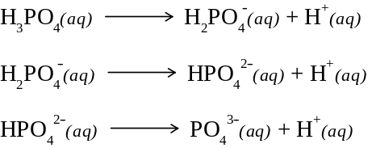

24. A student performed a neutralisation reaction outlined as followed: She took care to ensure complete neutralisation had occurred, with neither acid nor base in excess. She then used an indicator to measure the pH of the final reaction mixture. When she did this procedure with hydrochloric acid that was neutralised with sodium carbonate solution the final pH was approximately 4. She thought the pH would have been 7. Account for the observed pH value she found.
[3 marks]

The neutralisation reaction is as follows:

The CO₂(g) reacts with water to form carbonic acid which makes the system slightly acidic and so a pH less than 4 is observed.

25. Identify each of the following as a Strong Electrolyte (SE), a Weak Electrolyte (WE) or a non-electrolyte (NE):
[6 marks]
(a) HCl SE

(b) CH₃COOH WE

(c) NaCl SE

(d) NaOH SE

(e) H₂O NE

(f) C₆H₁₂O₆ NE

26.

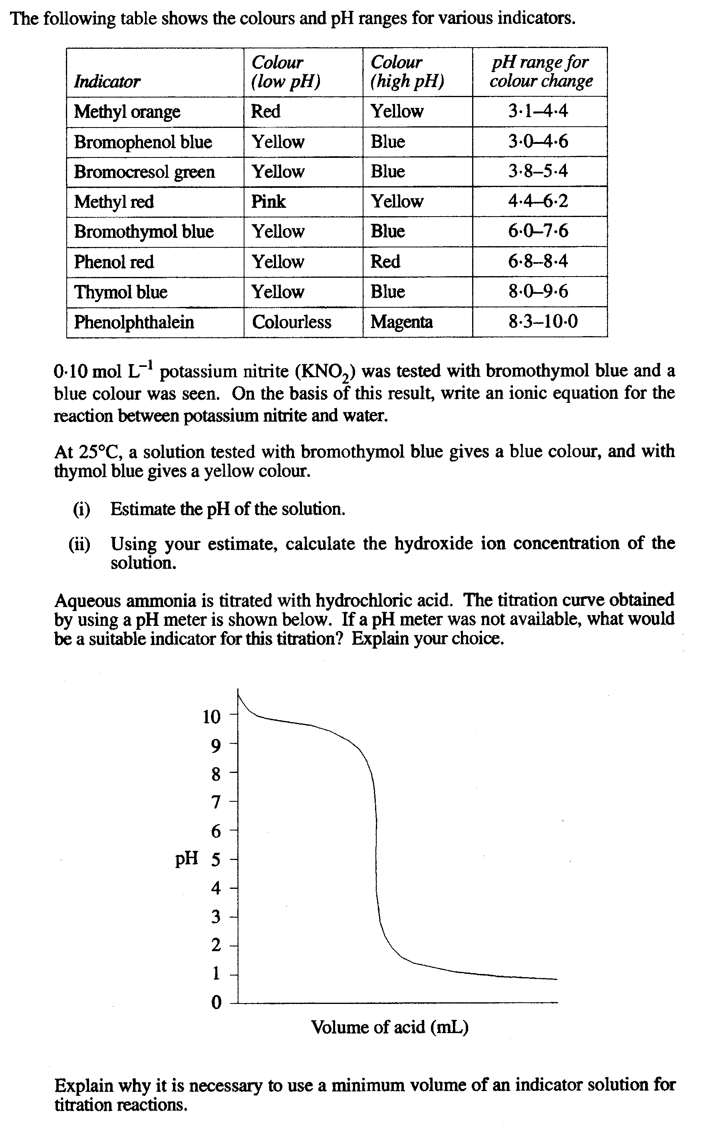
(a)
[1 mark]

(b)
7.6-8.0
[3 marks]

Take a value between 7.6 and 8.0, say 7.8

pOH = 14-7.8 = 6.2
[OH-] = 10^{-6.2} = 6.3 x 10⁻⁷ M

PLEASE TURN OVER

(c)
[3 marks]

Any indicator where a pH change is between the lines indicated. Lines are points of dramatic pH change. Hence, methyl red would do (others also).

27.

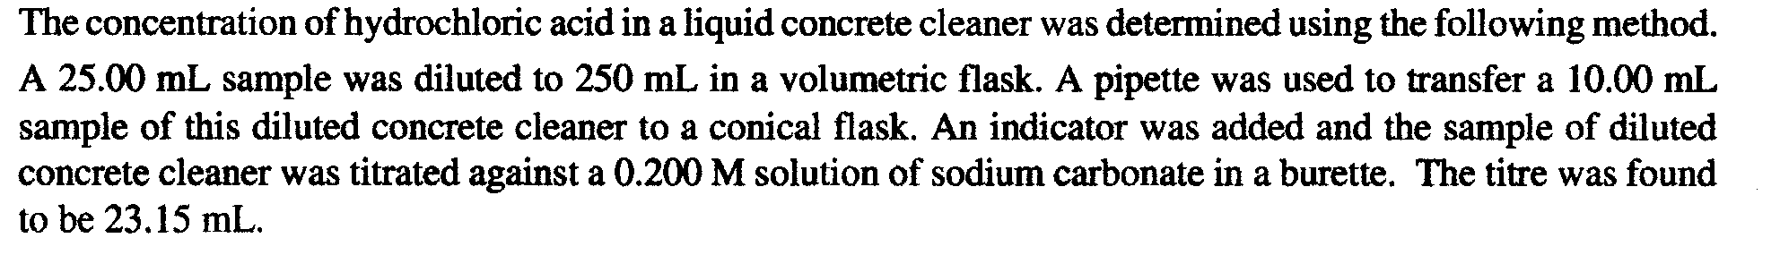
(a) Calculate the concentration of HCl in the original sample of concrete cleaner.

Na₂CO₃
c = 0.200 mol L⁻¹
V = 0.02315 L
A

C
D
250 mL

Cleanser with HCl

25.00 mL
10.00 mL
B

n(Na₂CO₃)_{A} = cV = 0.200 x 0.02315 = 0.00463
n(HCl)_{B} = 2 x n(Na₂CO₃)_{A} = 2 x 0.00463 = 0.00926 mol
c(HCl)_{C} = (n(HCl)_{B})/0.0100 = 0.00926/0.01 = 0.926 M
n(HCl)_{C} = cV = 0.926 x 0.250 = 0.2315 mol
c(HCl)_{D} = n/V = 0.2315/0.025 = 9.26 M

(b)
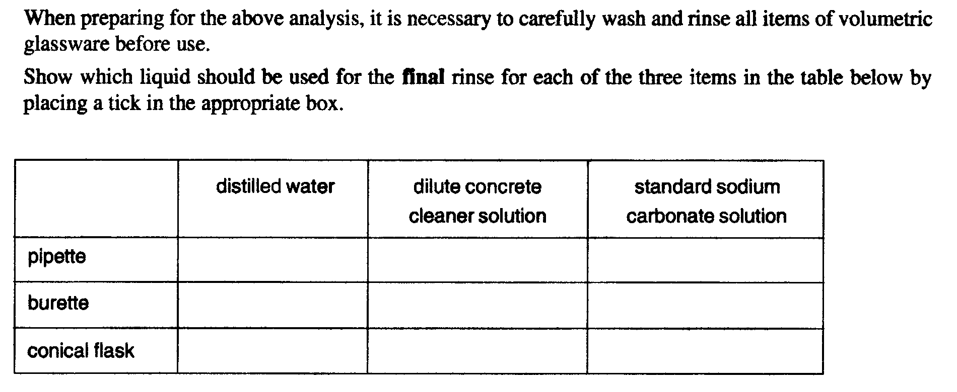
[3 marks]
✓
✓
✓

28.

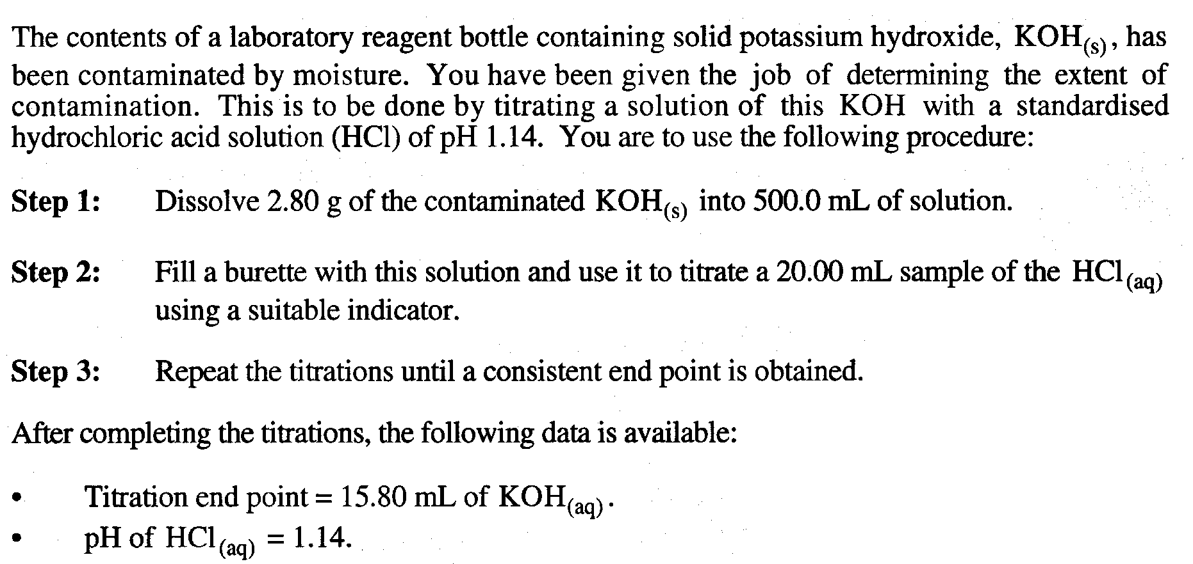

Calculate the percentage by mass of moisture in the contaminated KOH(s)

500 mL
B
C
D
2.80 g Impure KOH
KOH
V = 0.01580 L

A

HCl
pH = 1.14
V = 20.0 mL

n(HCl)_{A} = cV = 10^{-1.14} x 0.020 = 1.45 x 10⁻³ mol
n(KOH)_{B} = n(HCl)_{A} = 1.45 x 10⁻³ mol
c(KOH)_{B} = n/V = (1.45 x 10⁻³)/0.01580 = 9.17 x 10⁻² M
c(KOH)_{C} = 9.17 x 10⁻² M
n(KOH)_{C} = c x V = (9.17 x 10⁻²) x 0.500 = 0.0459
m(NaOH)_{D} = n x M = 0.0459 x 56.1056 = 2.58 g
%(KOH) in impure sample = (2.58/2.80) x 100 = 92.0%

29.

A supermarket brand of vinegar is to be analysed for its ethanoic acid content by a titration technique. This requires the preparation of a Na₂CO₃(aq) primary standard. The primary standard is made by dissolving 1.416 g of anhydrous Na₂CO₃(s) in some distilled water and making the solution up to exactly 500.0 mL using a volumetric flask.

A 50.00 mL sample of the vinegar is diluted to exactly 1.000 L in another volumetric flask. Four 25.00 mL samples of this solution are placed into separate conical flasks and titrated with the Na₂CO₃(aq) primary standard. On average 23.55 mL of the Na₂CO₃ solution was required for equivalence.

Na₂CO₃(aq) + 2CH₃COOH(aq) -------> 2NaCH₃COO(aq) + H₂O(l) + CO₂(g)

Determine the percentage by mass of ethanoic acid in the undiluted vinegar if this vinegar has a density of 1.060 g mL⁻¹.
[10 marks]

Vinegar
50.00 mL
1 L
25.00 mL
Na₂CO₃
V = 0.02355 L
D
C
D
1.416 g Na₂CO₃
E
B
A
500 mL
C

F

n(Na₂CO₃)_{A} = m/M = 1.416/105.9884 = 1.336 x 10⁻² mol
c(Na₂CO₃)_{B} = n/V = (1.336 x 10⁻²)/0.500 = 2.67 x 10⁻² M
n(Na₂CO₃)_{added from Burette C} = cV = (2.67 x 10⁻²) x 0.02355 = 6.29x 10⁻⁴ mol
n(CH₃COOH)_{D} = 2 x n(Na₂CO₃)_{added from Burette C} = 2 x (6.29x 10⁻⁴) = 1.26 x 10⁻³ mol
c(CH₃COOH)_{E} = n/V = (1.26 x 10⁻³)/0.02500 = 5.03 x 10⁻² M
n(CH₃COOH)_{E} = cV = (5.03 x 10⁻²) x 1 = 5.03 x 10⁻² mol
c(CH₃COOH)_{E} = n/V = (5.03 x 10⁻²)/0.0500 = 1.01 M

density of vinegar = 1060 g / L
therefore, mass of 1 L solution = 1060 g
number of moles CH₃COOH in 1 L = 1.01
therefore, mass of CH₃COOH in 1 L = n x M = 1.01 x 60.0519 = 60.5g
%(CH₃COOH) = [(mass of CH3COOH)/(mass of solution)] x 100
= (60.5/1060) x 100 = 5.7%

